**Iteration Plan 2:**

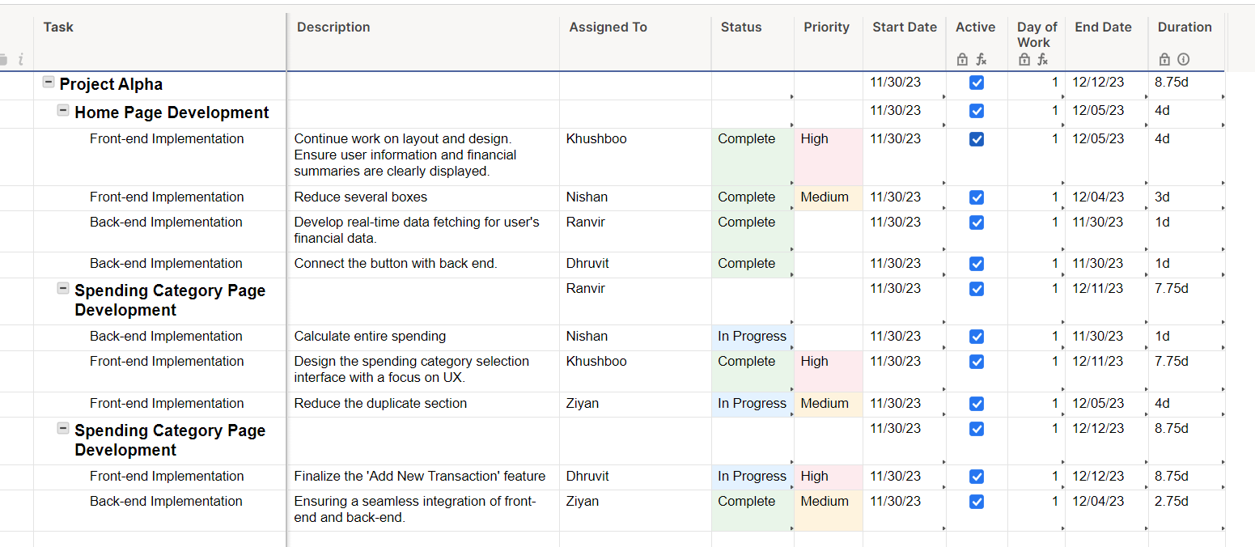**Gantt view:**

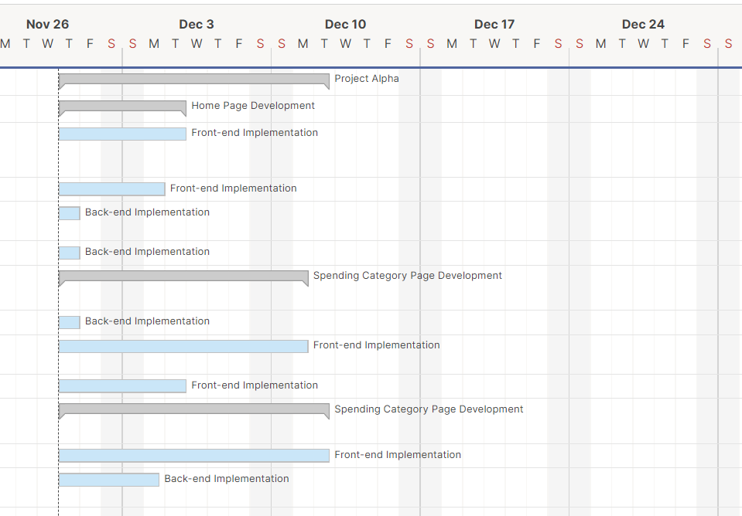

Card view:

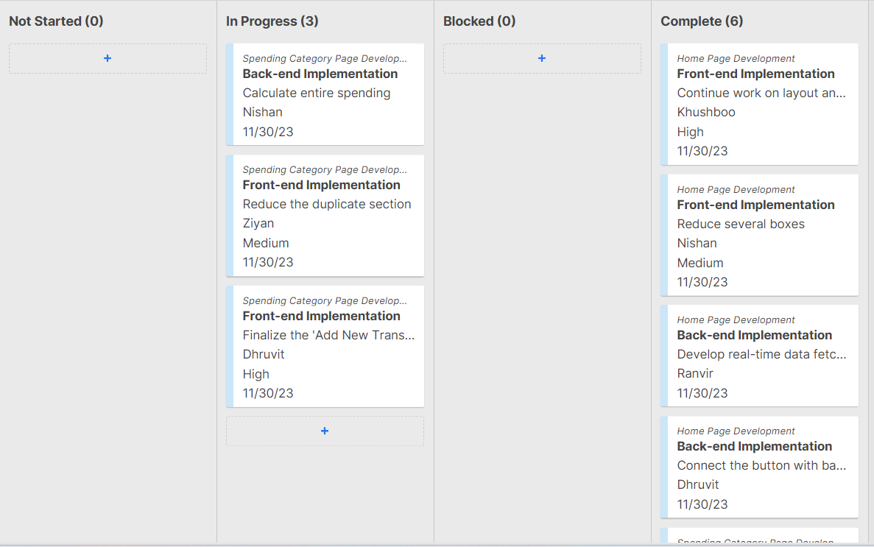

**Homepage Testing Table**

|  |  |  |  |  |  |  |  |
| --- | --- | --- | --- | --- | --- | --- | --- |
| **Element** | **Description** | **Expected Outcome** | **Actual outcome** | **Pass**  **/Fail** | **Start Date** | **End Date** | **Tested By** |
| Header | Presence of a header with navigation links | Header is present with links to Home and Add New Spending | [✓] | Pass | 30-11-2023 | 01-12-2023 | Dhruvit |
| Navigation Links | Functionality of navigation links | Clicking on Home navigates to the homepage, Add New Spending navigates to the respective page | [✓] | Pass | 29-11-2023 | 29-11-2023 | Ziyan |
| Key Features | Presence and functionality of key features | Features are visible and work as intended | [✓] | Pass | 30-11-2023 | 30-11-2023 | Khushboo |
| Monthly Spendings Table | Accuracy and completeness of the spending data | All transactions are displayed accurately | [✓] | Pass | 28-11-2023 | 29-11-2023 | Ranvir |
| Add New Spendings Button | Functionality of the "Add New Spendings" button | Clicking on the button navigates to the respective page | [✓] | Pass | 29-11-2023 | 30-11-2023 | Nishan |
| Download Mobile App Button | Functionality of the "Download Mobile App" button | Initiates the download or directs to app store | [✓] | Pass | 28-11-2023 | 28-11-2023 | Ranvir |
| Footer | Presence of a footer with necessary information | Footer is present with relevant information | [✓] | Pass | 01-12-2023 | 01-12-2023 | Ziyan |

**Add New Spending Page Testing Table**

|  |  |  |  |  |  |  |  |
| --- | --- | --- | --- | --- | --- | --- | --- |
| **Element** | **Description** | **Expected Outcome** | **Actual outcome** | **Pass**  **/Fail** | **Start Date** | **End Date** | **Tested By** |
| Header | Presence of a header with navigation links | Header is present with links to Home and Add New Spending | [✓] | Pass | 30-11-2023 | 01-12-2023 | Ziyan |
| Navigation Links | Functionality of navigation links | Clicking on Home navigates to the homepage, Add New Spending navigates to the respective page | [✓] | Pass | 29-11-2023 | 29-11-2023 | Ranvir |
| Form | Accuracy and completeness of the input form | Form includes fields for Date, Day, Transaction ID, Place, Time, Category, and Amount | [✓] | Pass | 01-12-2023 | 01-12-2023 | Dhruvit |
| Submit Button | Functionality of the "Submit" button | Clicking on submit adds a new transaction to the Monthly Spendings table on the homepage | [✓] | Pass | 30-12-2023 | 01-12-2023 | Khushboo |
| Monthly Spendings Table | Verification of the updated Monthly Spendings table | The Monthly Spendings table is updated with the new transaction | [✓] | Pass | 28-11-2023 | 30-11-2023 | Nishan |
| Footer | Presence of a footer with necessary information | Footer is present with relevant information | [✓] | Pass | 01-12-2023 | 01-12-2023 | Khushboo |

Disaggregated Tasks for the Spending Category Page

|  |  |  |  |
| --- | --- | --- | --- |
| **Constituent Task** | **Assigned Member** | **Expected Hours** | **Specific Functionality** |
| Category Visualization | Nishan | 14 hours | Implement visually appealing charts and graphs for spending categories, ensuring intuitive representation of data to enhance user understanding. |
| User Feedback Integration | Ziyan | 12 hours | Develop a system for collecting user feedback on spending categories. Implement user feedback loops to gather insights and improve user experience. |
| Enhanced Data Security Measures | Ranvir | 16 hours | Strengthen data security for spending categories. Implement advanced encryption mechanisms and conduct thorough security audits for enhanced protection. |
| Mobile Optimization | Khushboo | 10 hours | Optimize the Spending Category Page for mobile responsiveness. Ensure seamless functionality and a user-friendly experience on various mobile devices. |
| User Testing for Spending Categories | Dhruvit | 15 hours | Conduct comprehensive user testing for the Spending Category Page. Gather feedback, identify potential improvements, and ensure optimal user interaction. |

**Disaggregated tasks for Add a new spending:**

|  |  |  |  |
| --- | --- | --- | --- |
| **Constituent Task** | **Assigned Member** | **Expected Hours** | **Specific Functionality** |
| Create UI Components | Khushboo | 15 hours | Create a webpage named "Add a New Transaction" featuring input sections for users to specify the amount of money spent, select a category (such as food or rent), and input the date of the transaction. Include a "Submit" button to finalize and confirm the user's input. |
| Backend Logic | Ranvir | 14 hours | Establish backend capabilities to receive and process user inputs from the "Add a New Transaction" section. Ensure thorough validation of the provided information, verifying non-negative numerical entries and valid date formats. |
| Database Integration | Nishan | 12 hours | Establish a connection between the capability and the database system to store data related to new spending transactions. Develop the database structure, including attributes such as quantity, category, and timestamp, to effectively support and record spending events. |
| Return to Home Page selection | Ziyan | 10 hours | Upon successful addition of a new spending transaction, redirect the user to the home page. Integrate the updated data into the monthly spending total showcased on the homepage. |
| User Feedback for transaction submission | Dhruvit | 12 hours | Implement feedback messages or notifications to inform users about the success or failure of their transaction submission. In case of validation issues, deliver specific failure messages to address any problems encountered during the submission process. |